# Manual of Plugin：list_search_bar_plugs

--Power by DHM.

### Add SeachBar to web page:

1. Click “Add”

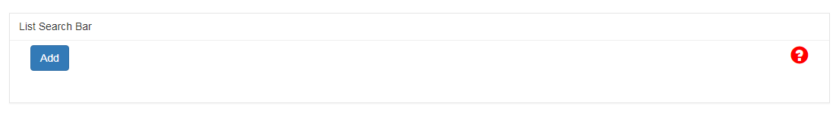

**Picture A**

2. Select the Product Types, Format, and Species that restrict user queries.(eg. Picture B Step 1 to 3)

3. Save Settings (Picture B Setp 4)

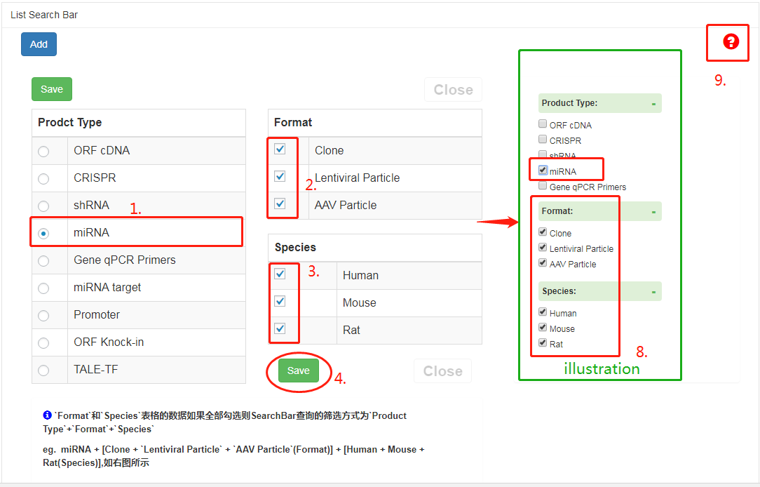

**Picture B**

4. After saving the Settings, short code is produced and then copied to the post. (eg. Picture C Step 5.)

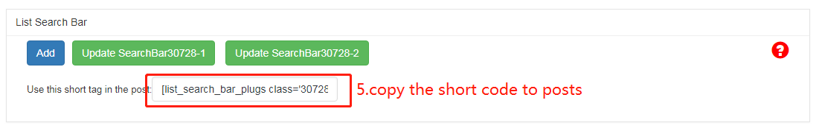

**Picture C**

5. Paste the short code in step 4 in the current article editor.(eg.Picture D Step 6)

You can also modify the display information and width of the search bar.

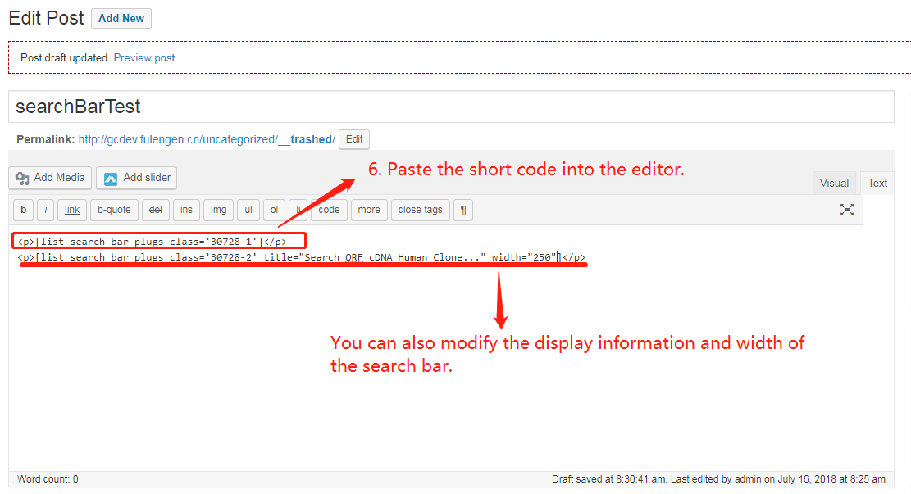

**Picture D**

6. Enter the product you want to search for, then click the search button.(Picture E Step 7.)

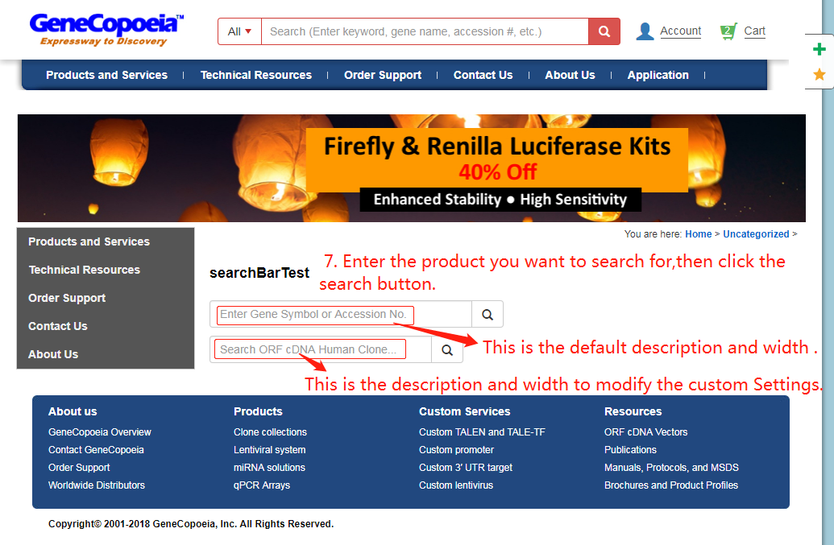

**Picture E**

7. Enter the keyword you want to search for and click the search button. Finally, the search results shown in figure F are obtained.(eg. Step 8 of figure B is the illustration shown here.)

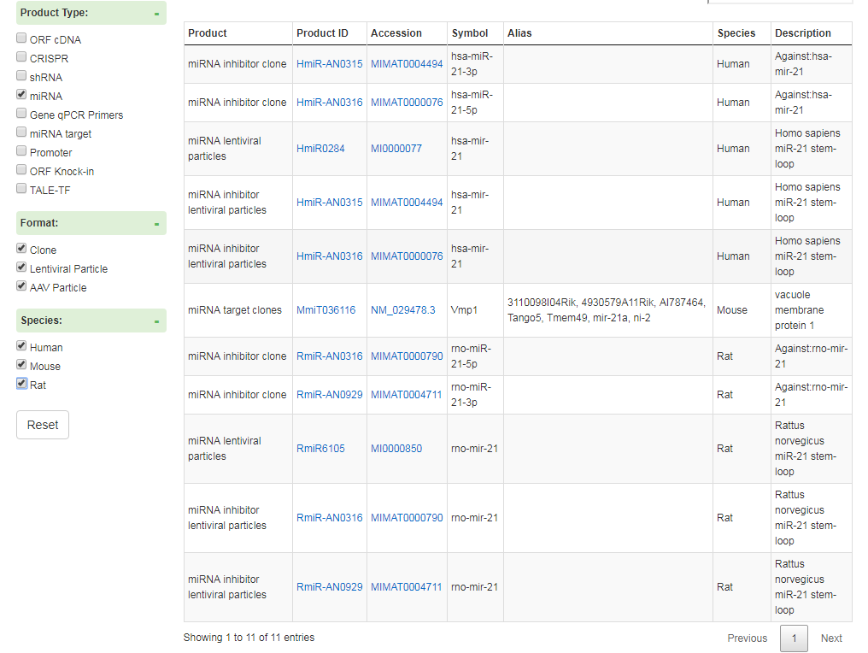

**Picture F**

8. This documentation can be downloaded at step 9 in figure B.

Thanks